### 

### Semester Two Examination, 2020

### Question/Answer booklet

# MATHEMATICS SPECIALIST

**UNITs 3 & 4**

## Section One:

## Calculator-free

|  |
| --- |

Your Name

Your Teacher’s Name

## Time allowed for this section

Reading time before commencing work: five minutes

Working time: fifty minutes

## Materials required/recommended for this section

***To be provided by the supervisor***

This Question/Answer booklet

Formula sheet

***To be provided by the candidate***

Standard items: pens (blue/black preferred), pencils (including coloured), sharpener, correction fluid/tape, eraser, ruler, highlighters

Special items: nil

## Important note to candidates

No other items may be taken into the examination room. It is **your** responsibility to ensure that you do not have any unauthorised material. If you have any unauthorised material with you, hand it to the supervisor **before** reading any further.

| Question | Mark | Max | Question | Mark | Max |
| --- | --- | --- | --- | --- | --- |
| 1 |  | 6 | 5 |  | 6 |
| 2 |  | 5 | 6 |  | 11 |
| 3 |  | 9 | 7 |  | 6 |
| 4 |  | 7 |  |  |  |

**Structure of this paper**

| Section | Number of questions available | Number of questions to be answered | Working time (minutes) | Marks available | Percentage of examination |
| --- | --- | --- | --- | --- | --- |
| Section One:  Calculator-free | 7 | 7 | 50 | 50 | 35 |
| Section Two:  Calculator-assumed | 11 | 11 | 100 | 89 | 65 |
|  |  |  |  | **Total** | 100 |

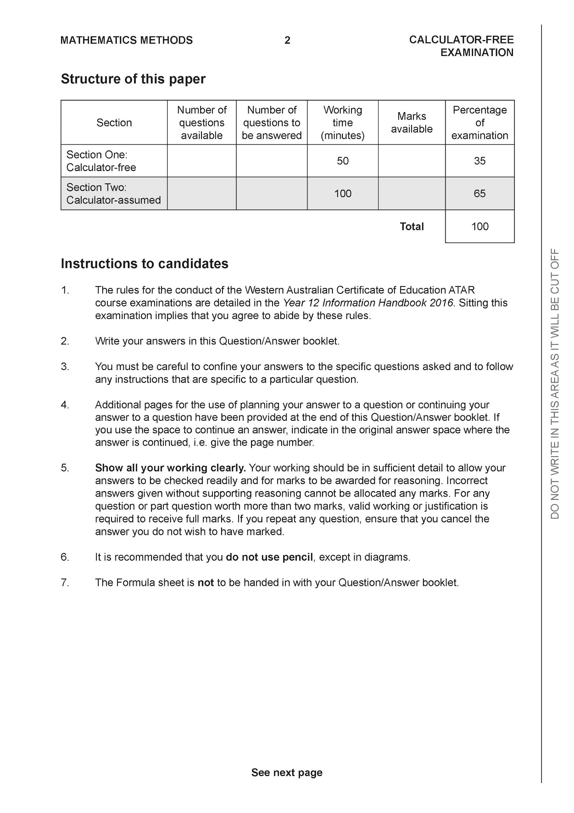

**Section One: Calculator-free (50 Marks)**

This section has **seven (7)** questions. Answer **all** questions. Write your answers in the spaces provided.

Spare pages are included at the end of this booklet. They can be used for planning your responses and/or as additional space if required to continue an answer.

● Planning: If you use the spare pages for planning, indicate this clearly at the top of the page.

● Continuing an answer: If you need to use the space to continue an answer, indicate in the original answer space where the answer is continued, i.e. give the page number. Fill in the number of the question that you are continuing to answer at the top of the page.

Working time: 50 minutes.

**Question 1 (6 marks)**

(a) (3 marks)



| **Solution** |
| --- |
|  |
| **Specific behaviours** |
| ✓ uses double angle identity  ✓ anti-diffs  ✓ adds a constant |

b) let (3 marks)



| **Solution** |
| --- |
|  |
| **Specific behaviours** |
| ✓ uses change of variable  ✓ obtains new integral with changed limits  ✓ determines exact value |

**Question 2 (5 marks)**

Consider the function where is a complex number.



1. Show that is a factor of . (2 marks)



| **Solution** |
| --- |
|  |
| **Specific behaviours** |
| ✓ uses value of -3i  ✓ evaluates each term and shows sum is zero |

1. Solve for all values for in the form . (3 marks)



| **Solution** |
| --- |
|  |
| **Specific behaviours** |
| ✓ uses conjugate of -3i  ✓ fully factorises  ✓ states four complex roots |

**Question 3 (3,4 & 2 = 9 marks)**

Given that where are constants.



1. Determine the values of . (3 marks)



| **Solution** |
| --- |
|  |
| **Specific behaviours** |
| ✓ solves for c with working  ✓ solves for a with working  ✓ solves for b with working |

1. Hence determine the exact value of. (simplify) (4 marks)



| **Solution** |
| --- |
|  |
| **Specific behaviours** |
| ✓ integrates using logs  ✓ integrates all terms  ✓ subs limits and obtains an exact value  ✓ simplifies result |

1. Explain why does not exist. (2 marks)



| **Solution** |
| --- |
| Discontinuous at x=-1,2 which is within interval |
| **Specific behaviours** |
| ✓ states discontinuous  ✓ states x values |

**Question 4 (3,3 & 1 = 7 marks)**

Consider the following functions:



1. Determine and its domain. (3 marks)



| **Solution** |
| --- |
|  |
| **Specific behaviours** |
| ✓ shows method for determining inverse  ✓ states inverse rule  ✓ states domain |

1. Determine and its domain. (3 marks)



| **Solution** |
| --- |
|  |
| **Specific behaviours** |
| ✓ states rule  ✓ solves for BOTH limit values for x  ✓ states both parts of domain |

1. Determine the solution(s), if any for , explain. (1 mark)



| **Solution** |
| --- |
|  |
| **Specific behaviours** |
| ✓ states that composite is always greater than zero |

**Question 5 (6 marks)**

Consider the function which is plotted below.



1. Plot on the axes above showing all major features. (3 marks)



| **Solution** |
| --- |
|  |
| **Specific behaviours** |
| ✓ reflected in line y=x  ✓ shows pt (3,4)  ✓ y less than 7 |

1. Given that , determine the defining rule for and its domain. (3 marks)



| **Solution** |
| --- |
|  |
| **Specific behaviours** |
| ✓ rearranges x and y  ✓ states rule  ✓ states domain |

**Question 6 (11 marks)**

Consider the function below.

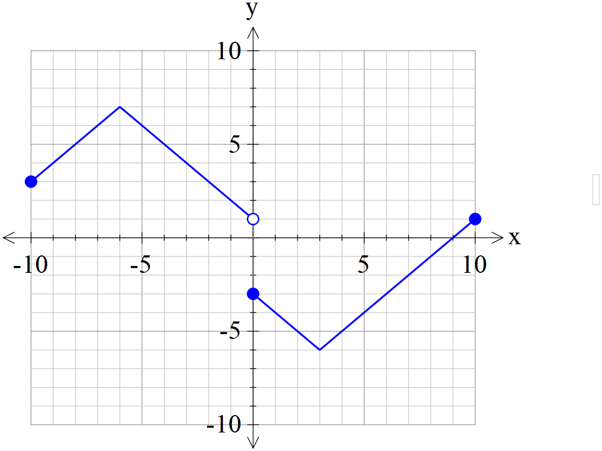

Sketch the following functions showing all major features.

1. (2 marks)



| **Solution** |
| --- |
|  |
| **Specific behaviours** |
| ✓ shows left is unchanged  ✓ reflects right in x axis |

1. (3 marks)



| **Solution** |
| --- |
|  |
| **Specific behaviours** |
| ✓ uses left side  ✓ reflects to give new right side  ✓ shows open circle on y axis and y intercept (0,-3) |

1. (3 marks)



| **Solution** |
| --- |
|  |
| **Specific behaviours** |
| ✓ uses right side  ✓ reflects in x axis  ✓ reflects in y axis for new left |

1. (3 marks)



| **Solution** |
| --- |
|  |
| **Specific behaviours** |
| ✓ shows asymptote with curve either side above x axis  ✓ shape  ✓ y intercept and open circle |

**Question 7 (6 marks)**

Using the substitution , evaluate the integral . (simplify)



| **Solution** |
| --- |
|  |
| **Specific behaviours** |
| ✓ uses du/dx  ✓ changes limits  ✓ obtains integral in terms of u only  ✓ uses partial fractions  ✓ obtains anti-derivative and subs limits  ✓obtains final value simplified  NOTE: Follow through only if partial fractions used) |

**Additional working space**

Question number:

**Additional working space**

Question number:

**Additional working space**

Question number: